A. Transfer to General Ledger

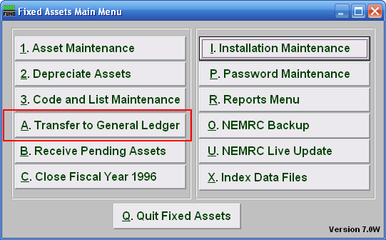
Click on “A. Transfer to General Ledger” from the Main Menu and the following window will appear:

Transfer to General Ledger

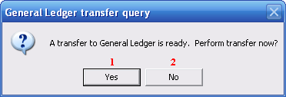
- Yes: Click on “Yes” if you want to transfer to General Ledger.

- No: Click on “No” if you want to cancel and return to the previous screen.

